5.Create a program that displays data from the sensor in regular intervals in a compact format.

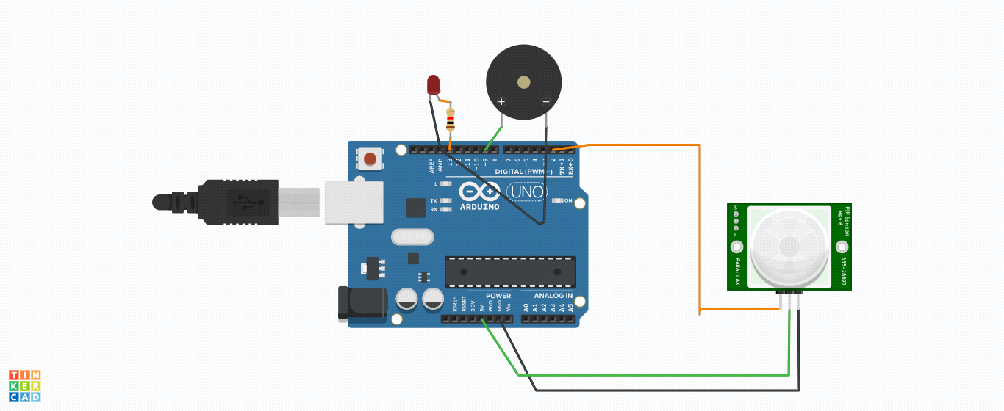

void setup()

{

pinMode(2, INPUT);

pinMode(13, OUTPUT);

pinMode(9, OUTPUT);

}

void loop()

{

if (digitalRead(2) >= HIGH) {

digitalWrite(13, HIGH);

tone(9, 523, 1000); // play tone 60 (C5 = 523 Hz)

} else {

digitalWrite(13, LOW);

noTone(9);

}

delay(1); // Wait for 1 millisecond(s)

}